**EyeVu, Developing a Retinal Scanner to Diagnose a Papilledema in Low Resource Environments**

Group Report By: Kitty Goodridge, Wesley Barrett, Dipanshu Gandhi, Alex Lawrence

**Initial Problem:**

In low resource countries, many citizens do not currently have access to brain scanning devices which are able to diagnose intracranial hypertension, which is a symptom of diseases which if left untreated could lead to death. An indicator of intracranial hypertension is papilledema which can be seen around the optic nerve in a scan of the retina shown in Figure 1. Therefore, the EyeVu project is aiming to design a low-cost device that can take an image of the retina, and give an initial diagnosis of papilledema, giving the patient an indication that they should get a brain scan. 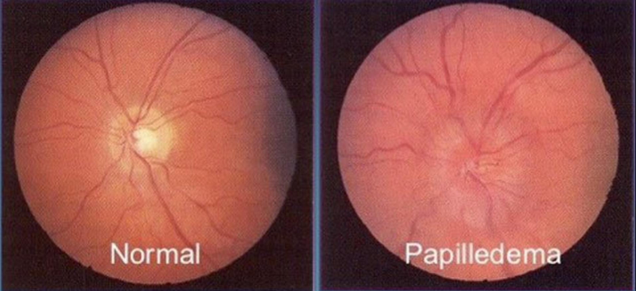

Figure 1: Comparison of normal retinal scan vs. a scan containing papilledema [1]

**Our Task:**

To solve this problem, we have been tasked with designing a proof-of-concept for this handled device, specifically proving the feasibility of using off-the-shelf camera and optics systems to capture an image of the retina (that is suitable for diagnosing a papilledema). Furthermore, we have also designed a prototype for the final device, focusing particularly on the electronics and lens moving mechanism

**Approach:**

To prove the feasibility of the device, we aim to:

1. Construct a rig for an optics system, that could be modified to be used in a handheld device
2. Design an optics system using low-cost lenses and theoretical calculations
3. Implement open-source, off-the-shelf electronics to develop a robust imaging system
4. Integrate all of the above components into a functional system (prototype for the final system) that proves the feasibility of a low-cost imaging system by taking photos of the retina using our system.

**Design constraints:**

* Optics should be less than 40cm long
* Device must be handheld
* Under £100 for the bill of materials (BOM)
* Operational by two or less people
* Can obtain an image of the retina of sufficient quality to detect papilledema

Furthermore, it was important for us to keep the context of where this device was being used in account. The cost of the device must be cheap, it must be able to withstand high temperatures, dust and water penetration, as well be simple to maintain and repair in low-resource contexts.

**Technical Summary:**

After completing our proof-of-concept study, we were able to prove that the constraints required were possible and that it was feasible to obtain an image from our own prototype. Furthermore, we also designed an automated and robust system to move the lens, allowing for an auto-focus mechanism to be later implemented - required due to the varying size of the patient's eyes. A prototype for the lens-moving mechanism in the final prototype was also developed, with electronics design and improved functionality and durability.

**Lens Design:**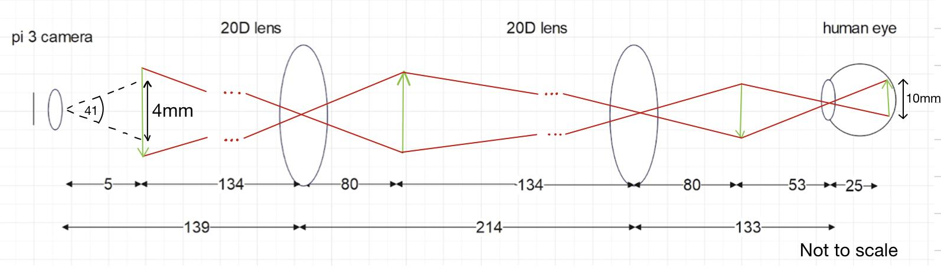

Figure 3: Ray Diagram for Lens Design

This design was built in line with our constraints for the project. Primarily the 20D lenses are the cheapest on the market and any higher strength lens has a large jump in price. For us this factor outweighed keeping the design within 40cm (total length of 50cm) as we designed a lightweight rig which would still be able to be handheld. As you can see from the diagram a 4x4 mm image of the optic nerve can be obtained which is all that is necessary to diagnose a papilledema and aligns with the software team’s requirements for the project.

**Mechanical Design:**

In order to test our design and lens arrangement quickly, we created a testing rig. This rig was manual, and allowed for easy alignment of the optics. Since the testing rig was designed for quick testing, the final mechanism is different - as it has a greater focus on reliability and durability. An in depth explanation of both designs can be found in the appendix.

**Electronics and Autofocus:**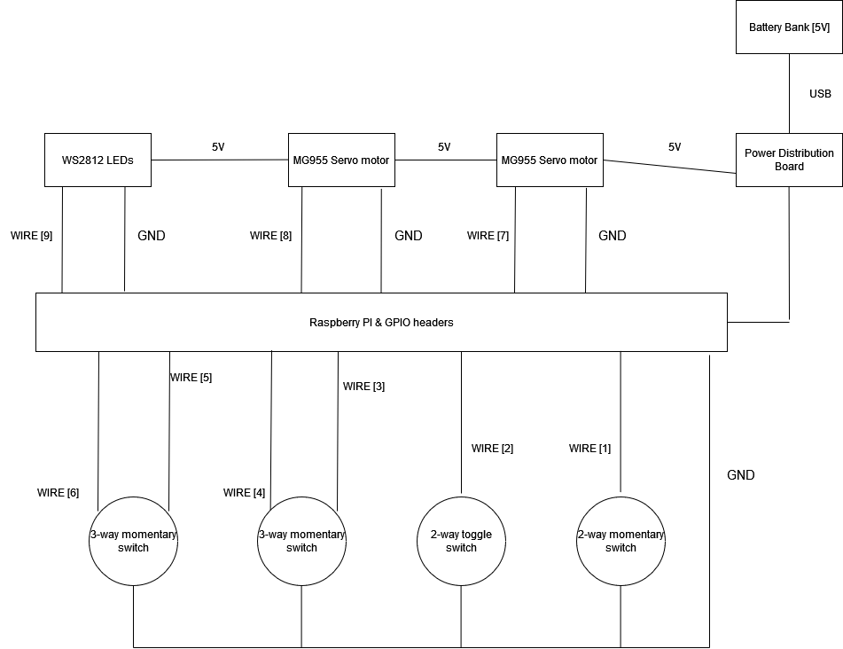

The GPIO pins on the raspberry pi were used to their full functionality, with the underlying software functions mainly delivered after the 2-way momentary switch is enabled on the GPIO input, enabling one of the three focus methods:

1. Taking NxN photos, outputting NxN photos. Moves each lens incrementally. User/software chooses best
2. Taking NxM photos, outputting N photos. moving one lens incrementally while 2nd lens position is optimised using fourier transforms
3. Taking one photo (two 3-way momentary switches will be used to move lens positions and manually focus)

The GPIO outputs are used to drive the motors and light the LEDs. There are 6 LEDs made into two rings and they light just before a photo is taken. *The 2-way toggle switch is used for lighting the LEDs manually.*

### Sustainable Development Goals

### Our project is in line with the overall vision of the sustainable development goals set by the UN, and the 4 main goals attributed to our aims and objectives are the following:

Figure 3: Sustainable Development Goals [2]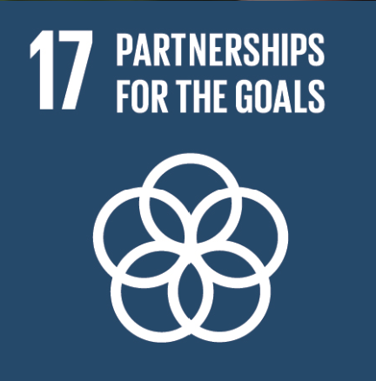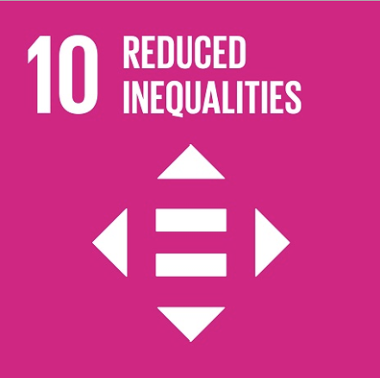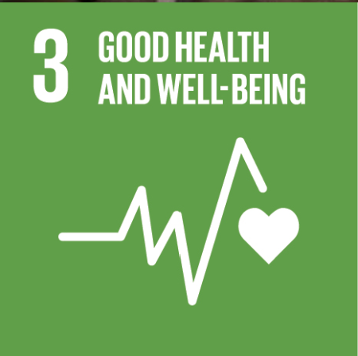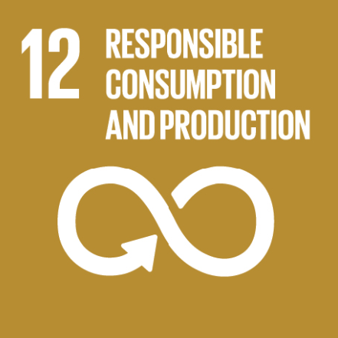

The 3rd goal, *‘health and well-being’* aims to improve health and well-being for all people and all ages around the world. Since our project’s main aim is to diagnose papilledema and therefore brain conditions associated with it, we would meet the 3rd goal as diagnosing papilledema in low-resource settings will of course improve the health and well-being of all people and all ages.

The 10th goal, *‘reduced inequalities’* aims to reduce inequalities around the world. The healthcare sector is extremely unequal, with poorer countries and poorer people having limited access to expensive ophthalmoscopes and well-trained professionals. This means the likelihood of diagnosis of papilledema in low-resource settings is low. Our project addresses this issue by creating a low-cost, hand-held ophthalmoscope, which can be used by 2 or less untrained people. The accessibility of such a device vastly increases in low-resource settings due to the cost and the usability of the device for non-skilled professionals, which should reduce inequalities within the healthcare sector.

The 12th goal, *‘responsible consumption and production’* aims to ensure consumption and production is sustainable and responsible. Our ophthalmoscope is made sustainably by minimising plastic usage whilst also using readily available lenses (20D) which many companies dispose of due to reasons not relevant to ophthalmoscopy. It is also a reusable device with many uses before wear and tear makes the device redundant and disposed of. The chosen motors use minimal energy consumption which conforms to responsible consumption of electricity and in turn reduces climatic impact.

The 17th goal, *‘partnerships for the goals’* aims to promote the effective implementation of sustainable development agendas by encouraging partnerships at all levels. It recognizes that achieving sustainable development requires collaboration between governments, private sectors and other stakeholders. The overall EyeVU project is centred around this goal as a large consortium with many different teams and stakeholders working towards developing a miniaturised endoscope camera. Our work is directly contributing towards this body of work. The project itself provides a strong avenue and framework for collaboration and communication between the different parties. These connections could also lead to future collaboration on many different issues. Additionally, the development of such a device also opens avenues for other forms of collaboration such as enhancing healthcare partnerships and mobilising financial resources. Strengthened partnerships between local healthcare providers, could potentially lead to the overall development and improvement of medical services in the target countries.

### Principles for Digital Development

Our project is aligned with the principles for digital development, and the 3 principles most closely aligned with our project are the following:

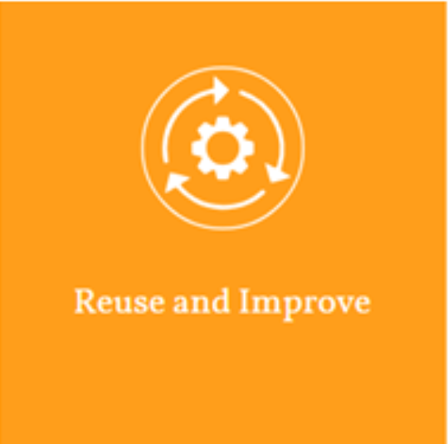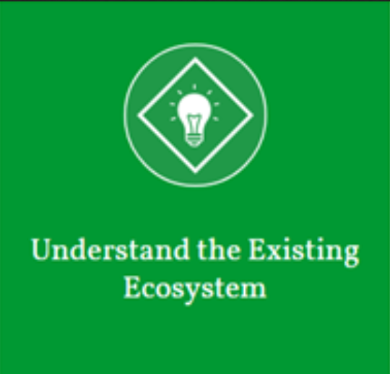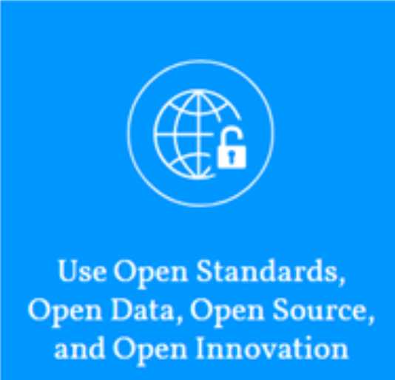

Figure 4: Principles for digital development [3]

**Reuse and Improve:**

Reuse and Improve embodies an approach that leverages pre-existing products, resources, and methodologies to accomplish program objectives, all while maintaining discretion about the source material. It also means to improve the existing material to make it more focused to the program’s goal and context. As such, we believe our project most closely aligns with this principle. When starting our design process, we considered current expensive, and cost-prohibitive medical-grade approaches to imaging the fundus, as well as previous DIY attempts to make a low-cost fundus imaging system. We reused key aspects of their design, such as using lenses to reduce the device's dimensions and using low-cost cameras. However, we also improved on their designs by using open-source components, improving the optics design, and creating a system that enables motorised auto-focusing. By taking inspiration from the successes and failures of previous projects, we have been able to create a high-quality, functional design in a short amount of time, that is adapted to the context where it will be used.

**Understanding the existing ecosystem:**

Gaining a thorough understanding of the existing ecosystem involves fully grasping the context in which the device/product/service will be used. This was a vital aspect of our approach and served as the guiding principle from the beginning of the project. Firstly, we assessed the need for such a device, identifying the key problems we could solve and the key stakeholders involved throughout the project's lifecycle. Once we recognized the demand for a cost-effective fundus imaging device, we carefully considered the essential features it must possess to function effectively in a low-resource environment with harsh climate conditions.

**Use Open Standards, Open Data, Open Source, and Open Innovation:**

The utilisation of Open Standards, Open Data, Open Source, and Open Innovation constituted a significant focal point in the latter stages of our design process, particularly during the selection of components and software libraries for the imaging system. We made a deliberate decision to employ a single-board computer and an imaging system that operates on open-source software libraries. This choice holds substantial importance, as it ensures that potential collaborators in future projects are not impeded by the utilisation of proprietary code. Moreover, it guarantees that any enhancements made to the camera and motor control libraries are seamlessly integrated into our final product. This approach allows us to concentrate on the crucial design aspects that exert the greatest influence on our product, namely durability, reliability, ergonomics, and the quality of the optics system. By doing so, we are able to circumvent the need for allocating an extensive amount of development time to software programming.

### Project Management

Our initial teamwork strategy consisted of splitting the project into 5 sections. We divided the workload into 4 modular sections; Optics, Camera, Electrical and Mechanical with one integral section being the Raspberry Pi. We chose this strategy as the 4 modular sections have minimal technical overlap and can be done without consulting the rest of the team, whilst the integral section has overlap with every other section requiring us to collaborate effectively to produce a functioning deliverable.

| Wes | Kitty | Dipanshu | Alex |
| --- | --- | --- | --- |
| Optics  Camera  Raspberry Pi | Optics  Camera  Raspberry Pi | Electrical  Mechanical  Raspberry Pi | Electrical  Mechanical  Raspberry Pi |

**Multiple Domain Matrix:**

| MDM | Optics | Camera | Electrical | Mechanical | RasPi | Wes | Kitty | Dipanshu | Alex |
| --- | --- | --- | --- | --- | --- | --- | --- | --- | --- |
| Optics | d | x |  |  | x | x | x |  |  |
| Camera |  | d |  |  | x | x | x | x |  |
| Electrical |  |  | d |  | x | x |  | x | x |
| Mechanical |  |  |  | d | x |  |  | x | x |
| RasPi | x | x | x | x | d | x | x | x | x |
| Wes |  |  |  |  |  |  | x |  |  |
| Kitty |  |  |  |  |  | x |  |  |  |
| Dipanshu |  |  |  |  |  |  |  |  | xx |
| Alex |  |  |  |  |  |  |  | xx |  |

O - Team 1: Kitty and Wes

O - Team 2: Dipanshu and Alex

**Advantages of using our approach:**

**1. Adaptive Planning:** We consistently reframed and prioritised tasks based on changing circumstances, such as delayed parts delivery or testing results. By discussing the impact and finding mitigation strategies, we ensured that the development timeline remained on track.

**2. Skill Utilisation:** During task allocation, we leveraged the team's existing strengths, considering individual expertise in prototyping, mechanics, electronics, and optics. This allowed us to optimise each team member's contribution and provide support when someone encountered challenges.

**3. Focus on Testing:** Recognizing the importance of practical validation, we shifted our emphasis from theoretical calculations to designing and constructing test rigs early on. This approach enabled us to complete project objectives within the limited timeframe and make informed decisions based on real-world data.

**4. Task Segmentation:** From the outset, we divided the larger problem into smaller, manageable tasks. By independently addressing aspects like lenses, electronics, and mechanics simultaneously, we ensured parallel progress and accelerated the overall development timeline.

**5. Collaborative Environment:** Maintaining teamwork and open communication was paramount. If any team member faced difficulties or was unable to complete their tasks due to illness, we quickly informed the team to arrange support without impeding project progress. Regular discussions also allowed for workload redistribution to ensure fairness and efficiency.

By implementing these strategies, we fostered a dynamic and adaptable working environment, enabling us to navigate challenges effectively and achieve our project goals with greater efficiency.

**Future improvements to our approach:**

**1. Integration Planning for Tasks:** While individual tasks were outlined, there could have been improved consideration of their interdependencies and contribution to the overarching project. This includes early identification of key milestones, such as the development of a final prototype, as well as the incorporation of essential tests, like motor functionality, at earlier stages. It is important to evaluate the value of conducting additional tests if consecutive testing becomes infeasible due to time constraints. For instance, given our limited time, investing effort in soldering the motor circuits may not have been worthwhile since we lacked sufficient time to test the automation. This time could have been better utilised by focusing on other critical areas.

**2. Design Exploration and Optimization:** While the development of ideas was expedited, more time could have been spent discussing different design options and selecting the optimal solution. Prioritising thorough design exploration before proceeding with implementation could have led to more efficient and effective outcomes.

**3. Timely Ordering of Parts:** Delays were encountered due to lengthy delivery times for crucial components like stepper motors. To maximise available time, it would have been advantageous to specify all required components before testing, anticipating future testing needs even at early stages of the project.

**4. Communication of Design Measurements:** Given the involvement of multiple team members in designing test rigs and prototypes, clear communication of design measurements was essential. Although designs were available on the GitHub repository, organising them more clearly and consolidating key measurements in a central document could have facilitated easier reference and collaboration. Some parts had to be remade or reworked because of dimension errors and there was misalignment of the holes in the base.

**5. Realistic Expectations:** Initial project planning exhibited ambitious timelines, which could have been improved by incorporating buffer periods between deadlines and task completion targets. Allowing flexibility for unforeseen issues, which are common in such projects, would have contributed to a more realistic and manageable project schedule. It is worth noting that improvements in managing expectations were observed as the project progressed.

By addressing these areas for improvement, the project team could enhance overall planning, design selection, procurement strategies, communication, and expectation management, leading to increased efficiency and better project outcomes.

### Appendix

**References:**

1. Image of papilledema, Ex-AIIMSdoctors.com, Accessed: 03/06/23
2. Sustainable Development Goals, <https://sdgs.un.org/goals>, Accessed: 03/06/23
3. Principles for digital development, <https://digitalprinciples.org/>, Accessed: 03/06/23

#### 

#### **Stationary Rig**

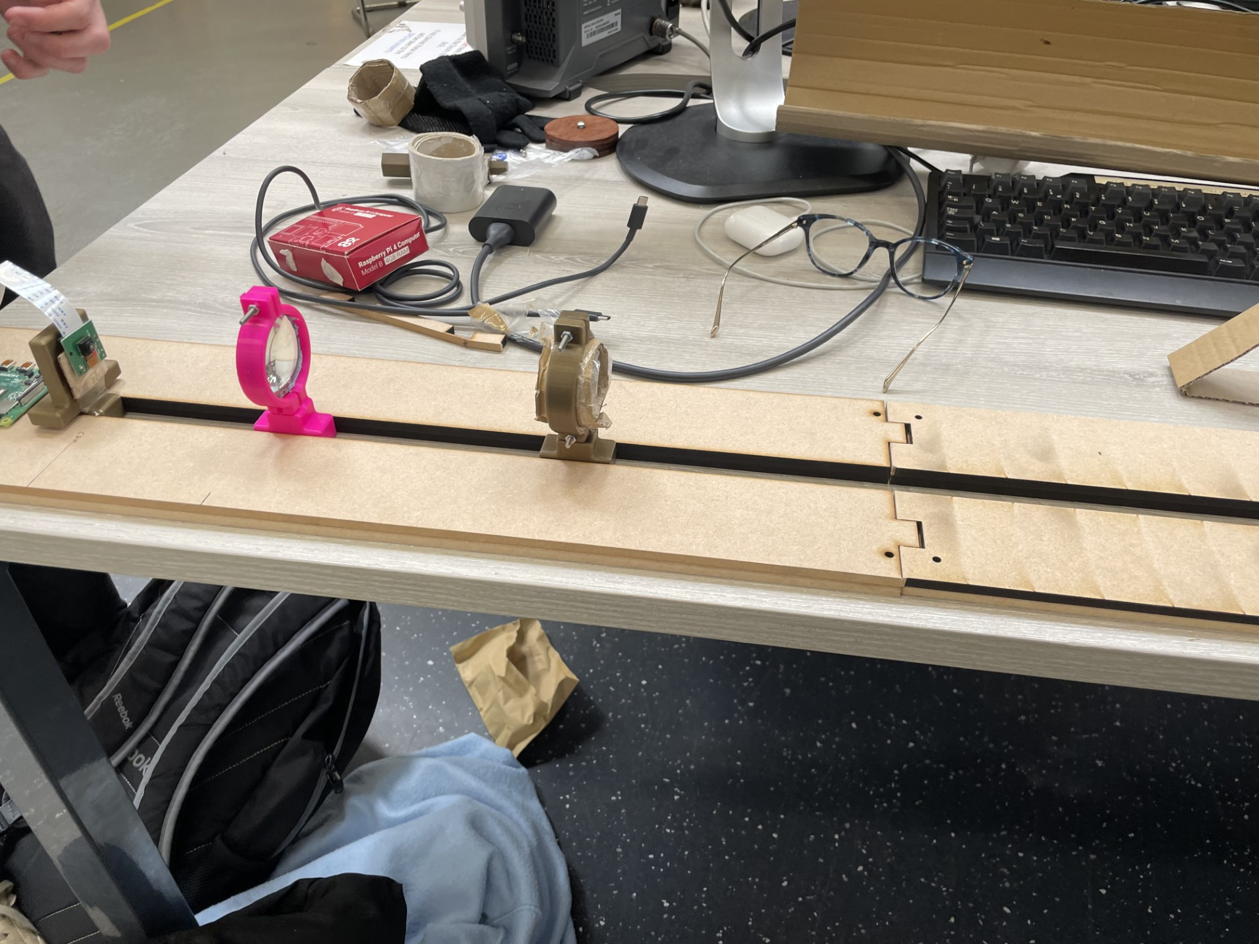

The initial test rig served the purpose of validating the calculated lens configurations and distances, as well as conducting camera capture testing. The design of this rig prioritised flexibility and efficiency. The construction process employed rapid prototyping techniques, utilising a 12mm (2 x 6mm) MDF base that was laser cut to incorporate a slot. The lens holders and camera mounts were designed in CAD and then 3D printed, featuring a specialised bottom part that fitted into the slot. To accommodate the unknown lens distances at the time, the rig offered a generous testable length of 90cm.

The movable lens holders facilitated easy positioning while maintaining alignment. This test rig proved highly effective in successfully completing all the intended tests. Its versatility makes it a recommended choice for future similar testing scenarios. With minimal modifications to the 3D printed components, it can accommodate various combinations of lenses, distances, and additional elements like testing lighting rings.

#### **Motorised Rig**

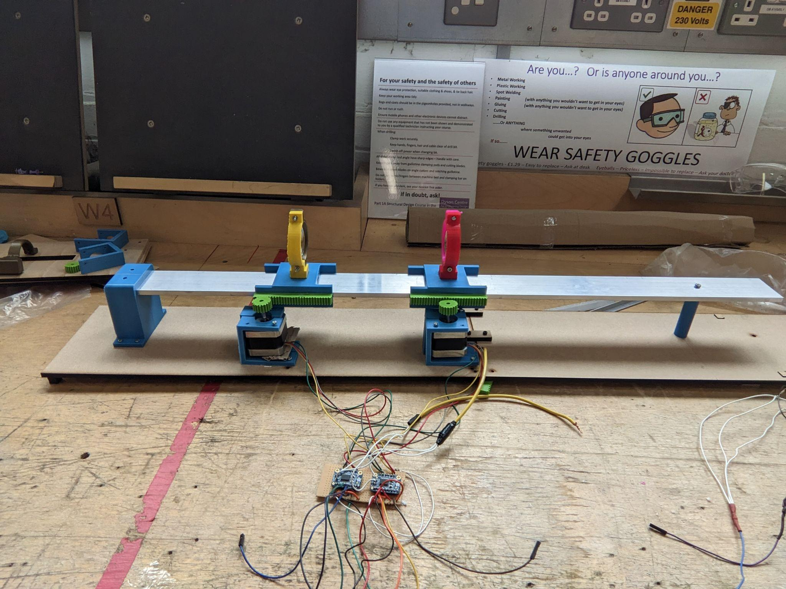

The motorised rig was an advancement from the manual design, integrating stepper motors to move the lenses. This was with the aim to create a mechanism that more closely resembled what could be used in the actual product. The rig featured an aluminium rod bar acting as a DIY linear rail along which 3D printed sliders with the lenses on could move. The sliders shape wraps around the rail so that they can only be taken on and off only from one end. The rail was raised to the height of the motors with 3D-printed parts to ensure proper alignment of the rack and pinion mechanism used. The rail and motors were mounted to an MDF base.

The mechanism successfully tested, although there was insufficient time to evaluate the autofocusing. Due to limitations of the rack and pinion it was decided to move to a more robust mechanism for the final prototype. **Considering the complexity and manufacturing requirements, it is recommended to construct a rig closer to the final prototype design if similar testing in the future is needed.**

### Final Prototype:

#### Mechanism**:**

The mechanism chosen was a scotch-yoke mechanism that reliably converts rotary motion (generated by precise stepping of the servo motors) into linear motion. It uses 2 aluminium tubes as linear rails (they are cheap and lightweight), and uses 3D printed parts for the rest. Torque calculations were carried out to ensure the motors were suitable, and mass calculations were carried out to ensure that the assembly was lightweight. The mechanism has been successfully tested in simulation, and we look forward to seeing the results when it is manufactured and tested physically.